 | BOROUGH OF AVALON  CONSTRUCTION DEPARTMENT  3100 Dune Drive  Avalon, NJ 08202  edean@avalonboro.org | Construction Official  Fire Subcode Official  Floodplain Administrator  Phone (609) 967-5920  Fax (609) 967-4140

NONCONVERSION AGREEMENTS - PROCESS

In accordance with Chapter 19 of Avalon Borough Code, Floodplain Damage Prevention Regulations, Section 19-15.2.; for habitable structures, the Floodplain Administrator determines when a non-conversion agreement is required for enclosed spaces below the design flood elevation. When required, the approved form of the non-conversion agreement shall be forwarded to the owner for completion and submittal to the Borough. The form and procedure to be used for receiving and filing the non-conversion agreement is set forth below, namely:

- When required, the document must be signed by all record owners and signatures must be acknowledged by a notary public
- The document is then returned to the Floodplain Administrator and the Floodplain Coordinator for review and approval, following which both will sign the document on behalf of the Borough, arrange for their signatures to be notarized, and then forward the completed document to the Borough Clerk
- The Borough Clerk will forward the document to the Cape May County Clerk for recording and return to the Borough Clerk.
- Upon receipt of the recorded document back from the Cape May County Clerk, the Borough Clerk will retain the original as a permanent record and provide a copy to the owners and to the Construction Office.

It will be the responsibility of the Floodplain Administrator and Floodplain Coordinator and Construction Official to index these deed restrictions and non-conversion agreements in the Construction Office in such a way that future enforcement is able to be conducted in a meaningful and efficient manner.

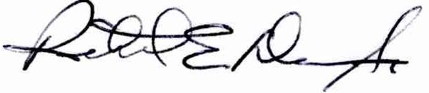
Richard E. Dean, Sr.
Construction Official
Fire Official
Floodplain Administrator

