Zoning Requirements:
Detached accessory structures
(Shed, cabana, pergola, gazebo)

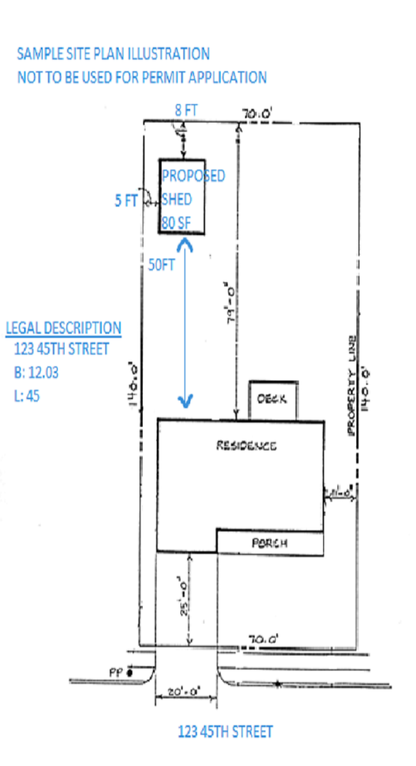
Less than 60 square feet
Minimum five (5) feet from the side and rear property line.
Minimum eight (8) feet from the house (this includes decks/porches attached to the house)
Maximum height, eight (8) feet.

60 square feet or larger
Minimum eight (8) feet from the rear property line.
Minimum five (5) feet from the side property line.
Minimum eight (8) feet from the house (this included decks/porches attached to the house)
Maximum height, twelve (12) feet.

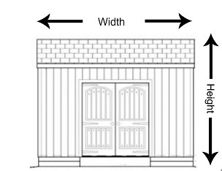

Zoning permit application required with survey/drawings showing location, setbacks, size, and height.

