Borough of Avalon Demolition Checklist
3100 Dune Drive aseltzer@avaloboro.org
Avalon, NJ 08202 (609)-967-7043
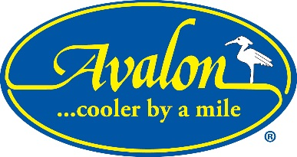

Demolitions are prohibited Friday to Monday of each Memorial Day weekend, and demolitions are prohibited July 1st through Labor Day Monday. There is an emergency provision.

___ Building Subcode Permit
___ Zoning Demolition Application
___ South Jersey Gas disconnect
___ Atlantic City Electric disconnect
___ Water/Sewer Disconnect- done by a NJ Licensed Plumber- call for inspection prior
to disconnect (609)-967-7043
___ Survey of existing property
___ Proposed landscape plan
___ Pictures of all four sides indicating which trees/shrubs are to stay or be removed
___ Asbestos abatement letter

