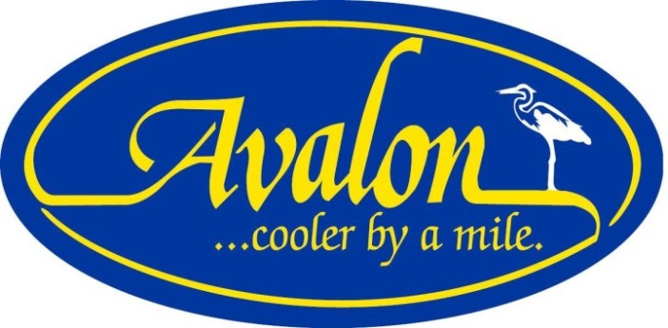

FREQUENTLY ASKED QUESTIONS REGARDING CONSTRUCTION ACTIVITY IN THE BOROUGH OF AVALON
Summer, 2018 update

There has been an increase in construction activity in Avalon during the summer of 2018. The Avalon Borough Council, Administration, and department heads are currently reviewing the rules and regulations for construction that will be fair for both the residents and contractors who do work in the Borough. Many further explanations of construction rules and regulations can be found in Chapter 20 of the Avalon Borough Code which you can find on the front page of the Borough website, www.avalonboro.net

Who Do I Call, and When/Enforcement: Enforcement may be made by the Code Enforcement Official; the Construction Official; or by any member of the Avalon Police Department. Avalon has expanded its dedicated Code Enforcement coverage to include all hours of allowable construction in Avalon, and one hour before and one hour after of allowable construction hours Monday through Friday, and during all allowable construction hours on Saturday. During all other hours, including Sunday, Avalon Police will respond to all alleged code violations

Online: You will find a tab on the front page of the Avalon municipal website labeled “Avalon Code Enforcement”. You can click on it and file your complaint through a program called “Citizen Serve”. This goes right to the Code Enforcement official on duty. That individual can, on site, respond to your complaint, take photos, issue warnings/summonses, and provide a response to your complaint while on site. The site is monitored by Code Enforcement Officers Paul Short and Lisa Sasdelli.

Telephone: You may call the Code Enforcement line at 609-967-5922 anytime. You will be provided with a list of options depending on the time you call. Calls may be forwarded directly to the Code Enforcement Officer on duty, or to the Avalon Police Department, depending on when the call is received. We suggest you exercise the option that will direct your call right to the cellular phone of the Code Enforcement Officer on duty as that individual is often in the field. Late night/early morning/or Sunday calls can go directly to the Avalon Police Department at 609-967-3411.

Traffic/Parking Violations: An active construction site does not mean give the contractor permission to block driveways to private properties, park the wrong way on the street, or other infractions. If you wish to report a violation involving a motor vehicle, please contact the Avalon Police Department directly at 609-967-3411.

Allowable Construction Hours: Offseason is defined as September 15th through June 14th; construction is permitted from 7:00am until 7:00pm daily. Summer season is defined as June 15th through September 14th; construction is permitted from 8:00am through 7:00am weekdays, and 9:00am-7:00pm Saturday and Sunday, however Sunday construction is prohibited from the Sunday of Memorial Day weekend through the Sunday of Labor Day weekend.

Allowable Demolitions: Demolitions are prohibited from July 1st through Labor Day; demolitions are prohibited from Friday-Monday of any Memorial Day weekend. Demolitions are allowed any other time during the year.

Dumpsters: Every construction site shall be equipped by a dumpster and to the extent possible, the dumpster must be located on the actual construction site rather than on a Borough street, right of way, or pavement. Dumpsters are to be covered during all hours when active construction is not occurring. If it is impossible to locate the dumpster on the property, the contractor may apply for a special permit to allow it to be located on the street.

Construction Fence: Each construction site shall have what is also known as a plywood silt fence, two feet in height, measured from grade, around either the entire construction site or disturbance provided. The fence may allow egress and ingress from the front of the site to the Borough street. Existing or new solid fencing and bulkheads that are 2’ or more in height are also considered silt fencing and the plywood isn’t needed as long as these other measures are maintained during construction.

Portable Toilets: Portable toilets are allowed on a construction site, at least eight feet back from the curb line and located on the actual construction site; they cannot be located on the public sidewalk or on the public right of way.

Building Materials: All building supplies and materials must be stored on the actual construction side and not on the sidewalk; it shall not be located in the public right of way. If it cannot be removed from the street at the end of the day, notification must be made in writing to the Code Enforcement Official, Construction Official, or Chief of Police for a temporary permit; that material must be moved to the site the next calendar day.

Construction Trailer Parking: Construction tool trailers may be parked without restriction at any time at or near any active construction sites, which are defined as having an active construction permit. Trailers defined as storage trailers, semi-trailers may not be parked on any Borough street from Friday, Memorial Day weekend through September 30th.

Installation of Swimming Pools: A dewatering permit is needed to prepare property for a swimming pool. The permit is valid for 60 calendar days from commencement of activity. If dewatering takes longer, an extension can be asked for, for seven days. Sediment bags are required to collect sand, gravel, dirt, and debris. The contractor is responsible for every area impacted by the dewatering process. Stop Work Orders may be issued for various violations (see 20-11.9).

Penalties for Violations/Repeat Violations:

20-11.14 Administrative Penalties and Assessment.
a. Any person violating this section shall be subject to such Administrative Penalties and Assessments as authorized by the New Jersey Uniform Construction Code. The Borough’s Construction Official shall impose and assess an administrative penalty for each day that a violation continues unabated and each day shall be treated as a separate and distinct violation.
b. Each day that a violation continues shall be treated as a separate violation and the penalty authorized under the UCC shall be imposed by the Construction Official.
c. Such penalties shall be recovered by the Borough through a Penalty Enforcement Action in accordance with N.J.S.A. 2A:58-11 and N.J.S.A. 52:27D-138.
d. Any Administrative Penalty imposed under this section shall be in addition to, and not in place of, any other penalty established in this section or by this Code.
(Ord. No. 729-2015)

20-11.15 Violations and Penalty.
Any person violating any of the provisions of this section shall, upon conviction, be subject to one (1) or more of the following:
a. For a First Offense:
1. A fine in the minimum amount of $100.00 not to exceed the sum of one thousand ($1,000.00) dollars; and/or
2. Incarceration for a term not to exceed ninety (90) days; and/or
3. A period of community service for a period not exceeding ninety (90) days.
b. For a Second or Subsequent Offense:
1. A fine in the minimum amount of one hundred ($100.00) dollars and not to exceed the sum of two thousand ($2,000.00) dollars; and/or
2. Incarceration for a term not to exceed ninety (90) days; and/or
3. By a period of community service for a period not exceeding ninety (90) days.
(Ord. No. 729-2015)

