atlanticcityelectric.com

September 29, 2017
Atlantic City Electric
5100 Harding Highway
Mays Landing, NJ 08330
800.642.3780

RE: Dune Drive, Borough of Avalon, County of Cape May

Dear Current Owner,

Atlantic City Electric Company is planning to rebuild our existing distribution line adjacent to your property along Dune Drive between 80th Street and 34th Street.

This work will comprise of replacement of all existing wooden poles and new conductors.

The work is scheduled to commence on or about October 15, 2017 and be completed by the end of the year.

Should you have any questions with regard to this work please feel free to contact Real Estate Specialist, Brooke Shetter at 609-625-5841.

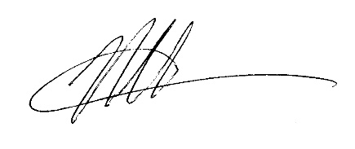
Sincerely,

Neil P. Baker, Manager
Real Estate
Atlantic City Electric

