# Avalon Borough Private Slip Dredging Checklist

## Checkmark graphic The following tasks must be done before the contractor is allowed to dredge your private slip in the Borough of Avalon

Sign, complete, and return the release form (both sides) provided by the Borough of Avalon

Sign, complete, and return the access agreement (both sides) provided by the Borough of Avalon

Provide a check for $300 made payable to the “Borough of Avalon” for both pre and post dredging inspection services provided by municipal engineer Hatch Mott MacDonald

Contact Mobile Dredging & Pumping Co. at (610) 497-9500 before work is to be conducted in your neighborhood and agree to a cost to dredge your private slip

*Note: Princeton Harbor will be dredged first in November, 2014. If your slip is on Princeton Harbor, it is imperative that you complete the tasks above at your earliest convenience. Once the dredge passes your slip, it will not return to dredge your slip*

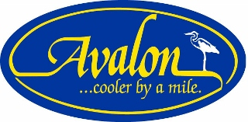

**Please note the following:**

-All updates on the Borough of Avalon dredging project are available on the Borough’s official website, [www.avalonboro.net](http://www.avalonboro.net) All forms are also posted on our website

-Please ensure that your release, access agreement, and check for pre and post inspection services are mailed or dropped off to:

Borough of Avalon Administration Office

Borough Dredging Project

3010 Dune Drive, Avalon NJ 08202

-Borough Hall is open Monday-Friday, 8:15am-4:15pm, except for official holidays. You may also call (609) 967-5917 for questions or additional information

-Under no condition will the dredging company return to dredge your slip after the dredge has passed your property