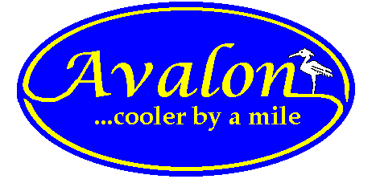

AVALON PLANNING & ZONING BOARD
SPECIAL MEETING
TUESDAY, APRIL 14, 2015 AT 5PM
HAS BEEN MOVED TO THE
COUNCIL ROOM

