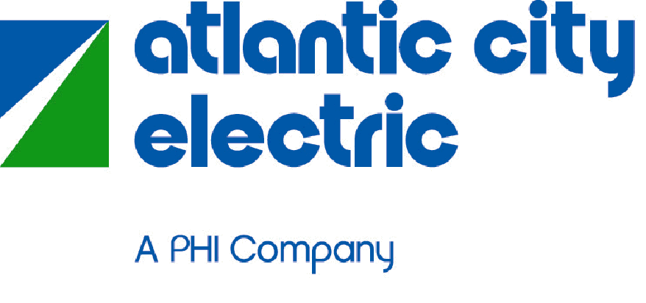
Peermont Project – Transmission Lines Fact Sheet
Project Need: The surrounding area has grown substantially in the last several years and has caused the existing substation and transmission lines serving this area to be near their load capacity. The existing 23kV Peermont substation must be re-built at 69kV to accommodate this load growth and to allow for continued growth in the area. The new substation will benefit the entire 7-mile Island and areas surrounding the causeways to the mainland.
Upgrades will also be completed on our existing transmission and distribution lines, which will connect to the new substation. We will be upgrading the existing 23kV transmission lines to new 69kV transmission lines in accordance with new standard steel pole designs required across the Atlantic City Electric service territory.
Over the last several years, our customers have experienced weather events that we never witnessed before: the blizzards of 2010, Derecho, Hurricane Sandy, and the March 2013 wind storm. The March 2013 wind storm had sustained 50mph winds for many hours that knocked 19 transmission poles down along Stone Harbor Boulevard which led to unplanned outages. To avoid future damage to our transmission poles, we are taking a proactive approach by installing new transmission poles that can withstand 120 mph winds.
The transmission portion of this project will replace wood poles with galvanized steel poles on the 7-mile Island and causeways leading to the island to protect against corrosion from the salt air and also to blend with the area environment. The new galvanized steel poles will be approximately 70 feet tall and will be designed to minimize impact on local migratory birds in the area. On the mainland, wood poles will be replaced with weathered steel poles to blend with the area environment.
In summary, these improvements will provide an upgraded network serving the immediate area and increased reliability for our customers.
Project Location: The majority of the rebuilt transmission and distribution lines will follow the current routes on the island as they exist today. The new substation will be located at the current Peermont Substation property at 271 61st Street in Avalon. The surrounding transmission and distribution lines extend to the boroughs of Avalon and Stone Harbor and to Middle Township.
Project Approvals: The project design is near completion. Our transmission line upgrades require a Waterfront Development permit, Coastal Wetlands Permit and a Tidelands License which will be obtained from the NJDEP. Authorization from the U.S. Army Corps of Engineers is also required and will be obtained prior to construction.
Storm Restoration: While we cannot guarantee that you will not have another power outage, the new substation and upgraded transmission lines will help us lower the risk of outages due to high winds, lightning, animal contacts, vehicle accidents or other factors. Contingency plans will be in place in the event we have any outages on the existing network until the upgrades can be completed.
Construction Information: Following receipt of approvals, preliminary construction work will commence in February 2015 through mid-May 2015, with a suspension of construction during summer 2015. Major construction will then occur from mid-September 2015 until mid-May 2016. Construction is scheduled to occur during the daytime and the majority of the work will be completed in the off season.
Facility Safety: Safety is a core value at Atlantic City Electric. Atlantic City Electric owns and safely operates over a hundred substations across our service territory without any adverse impact on residents’ health. The substation site will be an enclosed structure with security measures and will be continuously monitored and periodically inspected. As is practice with the hundreds of existing substations across our territory, we will provide access for the local fire department and we will work to help local firefighters become familiar with our facility.
Traffic: There will be personnel with equipment constructing the substation and transmission lines, but we will plan the work and coordinate with the Borough of Avalon to minimize disruptions or inconveniences to residents. Some of our transmission and distribution line upgrades will require daytime roadwork but we do plan to minimize disruptions and complete this roadwork in a prompt and timely fashion.
Project Updates: Ronnie Town, our public affairs manager on the project, will coordinate with all public officials. Our project team of engineers, planners and environmental experts will also be available should any questions arise that Ronnie cannot answer. Please contact Ronnie at 609-463-3805 or veronica.town@atlanticcityelectric.com with any questions.
Peermont Project Area of Benefit
Red – Primary Area of Benefit
Blue – Supplemental Area of Benefit
